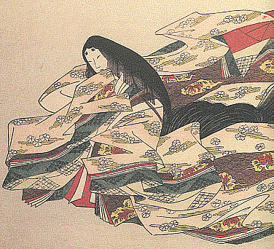

***The Beautiful Life of the Woman Komachi***

**VILLANOVA UNIVERSITY ASIAN STUDIES PROGRAM and VILLANOVA THEATRE**

**present**

A Staged Reading of a new play in five acts adapted from five short plays of Traditional Japanese Noh Theatre:

Depicting transformative events in the astonishing life of Ono no Komachi:

Japan’s best beloved and most admired woman

poet, beauty, lover, teacher, and ultimately spiritual adept.

**written by** Joanna Rotté, Professor of Theatre

**directed by** Elizabeth Dowd, Producing Director, Noh Training Project

**original music by** David Crandall, Theatre Nohgaku

*This event is free and open to the public.*

**Performances:**

Friday, January 18th at 7 PM

*Saturday, January 19th at 2 PM and 7 PM

Sunday, January 20th at 2 PM

*\*Saturday performances will feature Special Events.*

**Connelly Center Cinema**, **800 Lancaster Avenue, Villanova PA 19085**

**For tickets & information, visit www.villanovatheatre.org**